SAMPLE JENKINS CI-CD PIPELINE API
We are going to study on how to setup a Jenkins and docker base CI CD pipeline for an API project.
- Jenkins is used as automation server (Separated server)
curl ifconfig.me
display public ipv4 adddr of server
- Separate hosted server for the application
- Git and Github
- Docker and Docker compose
- Doppler as the wallet for environment variables
Jenkins hosted server – 20.193.255.237 Azure vm
Application hosted server - 20.193.137.245 Azure vm
Initial Setup on client VM =================================
1. install required packages
install git >
sudo apt update
sudo apt install -y git
install docker > (https://www.digitalocean.com/community/tutorials/how-to-install-and-use-docker-on-ubuntu-20-04)
lsb_release -a ( check os version )
sudo apt install apt-transport-https ca-certificates curl software-properties-common

Then add the GPG key for the official Docker repository to your system:
curl -fsSL https://download.docker.com/linux/ubuntu/gpg | sudo apt-key add -
Add the Docker repository to APT sources:
sudo add-apt-repository "deb [arch=amd64] https://download.docker.com/linux/ubuntu focal stable"

apt-cache policy docker-ce
sudo apt install docker-ce

sudo systemctl status docker
Output● docker.service - Docker Application Container Engine
Loaded: loaded (/lib/systemd/system/docker.service; enabled; vendor preset: enabled)
Active: active (running) since Tue 2020-05-19 17:00:41 UTC; 17s ago
TriggeredBy: ● docker.socket
Docs: https://docs.docker.com
Main PID: 24321 (dockerd)
Tasks: 8
Memory: 46.4M
CGroup: /system.slice/docker.service
└─24321 /usr/bin/dockerd -H fd:// --containerd=/run/containerd/containerd.sock
Check the command
sudo docker ps
install docker compose > (https://www.digitalocean.com/community/tutorials/how-to-install-and-use-docker-compose-on-ubuntu-20-04)
sudo curl -L "https://github.com/docker/compose/releases/download/1.29.2/docker-compose-$(uname -s)-$(uname -m)" -o /usr/local/bin/docker-compose
Next, set the correct permissions so that the docker-compose command is executable:
sudo chmod +x /usr/local/bin/docker-compose
To verify that the installation was successful, you can run:
docker-compose --version

You’ll see output similar to this:
Output
docker-compose version 1.29.2, build 5becea4c

2. install Doppler CLI

------------ # Debian 11+ / Ubuntu 22.04+ --------------------
sudo apt-get update && sudo apt-get install -y apt-transport-https ca-certificates curl gnupg curl -sLf --retry 3 --tlsv1.2 --proto "=https" 'https://packages.doppler.com/public/cli/gpg.DE2A7741A397C129.key' | sudo gpg --dearmor -o /usr/share/keyrings/doppler-archive-keyring.gpg

echo "deb [signed-by=/usr/share/keyrings/doppler-archive-keyring.gpg] https://packages.doppler.com/public/cli/deb/debian any-version main" | sudo tee /etc/apt/sources.list.d/doppler-cli.list

sudo apt-get update && sudo apt-get install doppler
------------- # Older versions of Debian/Ubuntu -----------------
sudo apt-get update && sudo apt-get install -y apt-transport-https ca-certificates curl gnupg curl -sLf --retry 3 --tlsv1.2 --proto "=https" 'https://packages.doppler.com/public/cli/gpg.DE2A7741A397C129.key' | sudo apt-key add –

echo "deb https://packages.doppler.com/public/cli/deb/debian any-version main" | sudo tee /etc/apt/sources.list.d/doppler-cli.list

sudo apt-get update && sudo apt-get install doppler
Now, verify the Doppler CLI was installed by checking its version.
doppler --version
You can also upgrade the CLI to the latest version at any time.
doppler update
chamalka@free-vm-student-profile:~$ doppler --version
v3.75.1
chamalka@free-vm-student-profile:~$ docker --version
Docker version 28.1.1, build 4eba377
chamalka@free-vm-student-profile:~$ docker-compose --version
docker-compose version 1.29.2, build 5becea4c
chamalka@free-vm-student-profile:~$

3. Configure password less Sudo access
Some Jenkins and automations tasks may require password less Sudo access
full password less access (with caution)
edit the sudoers file.
sudo visudo
Add the following line at the end
<username> ALL=(ALL) NOPASSWD: ALL
You can test it by running a sudo command:
sudo ls /root

This gives user full root privileges without a password. Better to use only in Controlled or trusted environments
password less access for specific commands (recommended)
for more secure setups, restrict sudo to only required commands
<username> ALL=(ALL) NOPASSWD:/usr/bin/tee /etc/nginx/sites-available/*, /usr/bin/ln -s……..
• Security Risk: Granting passwordless sudo access can be a security risk, especially if the account is compromised. Use it with caution.
• Scope: You can limit the scope of passwordless sudo by specifying particular commands instead of ALL. For example:
john ALL=(ALL) NOPASSWD: /usr/bin/apt-get, /usr/bin/systemctl
This configuration would allow the user john to run apt-get and systemctl commands without a password, but not other sudo commands.
By following these steps, you can configure passwordless sudo access on your Linux system.
4. Configure GitHub as a trusted source
Automatically trust the host
ssh-keyscan github.com >> ~/.ssh/known_hosts
For sometimes, need to run git clone first time
git clone git@github.com:<profile-name>/<repo-name>.git
5. Enable Git Pull via SSH

To allow the VM to pull code from a private GitHub repository, generate an SSH key on the client VM and add it to GitHub:

ssh-keygen -t rsa -b 4096 -C "example@jenkins"
cat ~/.ssh/id_rsa.pub

Then:
1. Go to GitHub - Settings -> SSH and GPG Keys - New SSH Key
2. Title it (e.g., example-test)
3. Paste the public key and click Add
6. Grant Docker Access to SSH User

sudo usermod -aG docker <username> (whoami for find the username)

Apply the group change without rebooting:

newgrp docker
7. Setup nginx

Install nginx

sudo apt install nginx

Enable nginx

ssh -o StrictHostKeyChecking=no <username>@<client-vm-ip> "sudo mkdir -p /etc/nginx/sit………………

Install certbot

sudo apt install certbot python3-certbot-nginx

Jenkins VM Setup =======================================
(Separate server)
1. Generate SSH Key Pair on Jenkins Server

ssh-keygen -t rsa -b 4096 -C "jenkins@azure-deploy"

File location: Press Enter (default ~/.ssh/id_rsa )
Passphrase: Leave empty

This generates:

. ~/.ssh/id_rsa - Private key

. ~/.ssh/id_rsa.pub - Public key

2. Copy Public Key to Client VM

ssh-copy-id -i ~/.ssh/id_rsa.pub <client-vm-username>@<client-vm-ip>
example - ssh-copy-id -i ~/.ssh/id_rsa.pub example-user-name@200.206.521.221

Accept the connection when prompted
Enter the Clients VM password
output:
Number of key(s) added: 1

Now try logging into the machine, with: "ssh 'example-user-name@200.206.521.221'"
and check to make sure that only the key(s) you wanted were added.
3. Install Jenkins on Jenkins server
We are going to download and install Jenkins on Jenkins server. Open source repository contains a Docker Compose configuration for a quick installation of Jenkins. But this setup is not great idea for production systems.
Since this is a fresh ubuntu VM, we need to first install docker and docker-compose, we can follow up the same previous guideline to install those.
https://github.com/vdespa/install-jenkins-docker
Clone this repository
git clone git @github.com…………..
Open a terminal window in the same directory where the Dockerfile from this repository is located. Build the Jenkins Docker image:
sudo docker build -t my-jenkins .
Start Jenkins:
Sudo docker compose up -d
check the running container status and detailer
sudo docker ps -a
If you wish to stop Jenkins and get back to it later, run:
docker compose down
Once you are done playing with Jenkins, maybe it is time to clean things up.
Run the following command to terminate Jenkins and to remove all volumes and images used:
docker compose down --volumes --rmi all
If the container was successfully up and running now we can navigate into Jenkins dashboard. By default, Jenkins run on 8080 port.
http://<localhost / server public ipv4 address>:8080

But this may be not work ( this url may be mnot reached ), Because this is a fresh server and not configured nginx. So we are trying to publicly access port (8080). This port can be closed to outside by the server vendors. Therefore we can set inbound configuration in cloud vendor dashboard and open the port to the public outside. But this will be secure vulnerable since the port expose the public world. The best approach is install nginx and configure nginx configuration to 8080 port.
Install nginx same as previous.
Configure nginx configure file (I am configuring default config file)
Initially I configured to http://ipaddr/jenkins -> but this Jenkins rewriting path rule caused into 500 internal server error
looked nginx logs and found this error.
rewrite or internal redirection cycle while internally redirecting to "/login///////////"
This means:
Set Jenkins URL (VERY IMPORTANT)
In Jenkins UI:
Manage Jenkins → Configure System
Set:
Jenkins URL: http://20.193.255.237

- Jenkins redirects /jenkins → /login
- Nginx rewrites /login back to /
- Jenkins again redirects → /login
- Infinite rewrite loop
- Nginx gives up → 500 Internal Server Error
This is caused by trying to force Jenkins under /jenkins using rewrites
Jenkins does not tolerate this well unless it is started with a context path.
Jenkins works BEST at /
Running it under /jenkins without changing Jenkins startup args will always cause problems (exactly what you’re seeing).
Serve Jenkins at ROOT /
URL:
http://200.193.255.200
following is the new configuration for serve Jenkins -> sudo docker restart <imgName>
location / {
proxy_pass http://localhost:8080;
proxy_redirect off;

proxy_http_version 1.1;
proxy_set_header Upgrade $http_upgrade;
proxy_set_header Connection "upgrade";

proxy_set_header Host $host;
proxy_set_header X-Real-IP $remote_addr;
proxy_set_header X-Forwarded-For $proxy_add_x_forwarded_for;
proxy_set_header X-Forwarded-Proto $scheme;

proxy_buffering off;
}
s

Open your web browser and navigate to http://localhost:8080 (or the port you configured). The "Unlock Jenkins" page will appear, prompting for the administrator password.

Retrieve the Initial Admin Password:
The password is automatically generated and stored within the container. You can retrieve it using one of the following methods:

From the Docker logs (easiest): View the logs of your running container. The password will be displayed there during the initial startup.

docker logs <container_name_or_id>
Then unlock Jenkins dashboard and complete the initial setup.
4. Jenkins setup
Install SSH Agent Plugin in Jenkins

. Go to Manage Jenkins - Plugins
. Search for SSH Agent Plugin
. Install and restart Jenkins if required

Add SSH Private Key to Jenkins Credentials

. Go to Manage Jenkins - Credentials - (global) - Add Credentials

. Select:

Kind: SSH Username with private key
Username: Jenkins vm username
Private Key: Select Enter directly, then run: (In Jenkins VM)
cat ~/.ssh/id_rsa (copy including header&footer)
and paste the output.
ID: azure-ssh-key (must match your pipeline)
Description: SSH key for Azure VM deployment
Click Save.
Skip for now
pipeline {
agent any
options {
disableConcurrentBuilds()
}

parameters {
string(name: 'REMOTE_HOST', defaultValue: '20.106.51.21', description: 'Remote Azure VM IP')
string(name: 'REMOTE_USER', defaultValue: 'icieos', description: 'Remote SSH Username')
string(name: 'APP_DIR', defaultValue: '/home/icieos/supreme-edits-api', description: 'App Directory on Remote VM')
string(name: 'REPO_URL', defaultValue: 'git@github.com:icieos-enterprise-org/supreme-edits-api.git', description: 'Git Repository URL')
string(name: 'BRANCH', defaultValue: 'main', description: 'Git Branch to deploy')
string(name: 'DOPPLER_PROJECT', defaultValue: 'supreme-edits-api', description: 'Doppler Project Name')
string(name: 'DOPPLER_CONFIG', defaultValue: 'prd', description: 'Doppler Config (env)')
}

environment {
SSH_OPTIONS = "-o StrictHostKeyChecking=no"
}

stages {
stage('Validate SSH Connection') {
steps {
sshagent(credentials: ['azure-ssh-key']) {
sh "ssh ${env.SSH_OPTIONS} ${params.REMOTE_USER}@${params.REMOTE_HOST} 'echo ✅ SSH connection successful'"
}
}
}

stage('Clone or Pull Code on Remote VM') {
steps {
sshagent(credentials: ['azure-ssh-key']) {
sh """
ssh ${env.SSH_OPTIONS} ${params.REMOTE_USER}@${params.REMOTE_HOST} '
set -e
if [ ! -d "${params.APP_DIR}/.git" ]; then
echo "📦 Cloning repository from branch: ${params.BRANCH}"
rm -rf ${params.APP_DIR}
git clone --branch ${params.BRANCH} ${params.REPO_URL} ${params.APP_DIR}
else
echo "🔄 Pulling latest code from branch: ${params.BRANCH}"
cd ${params.APP_DIR}
git fetch origin
git checkout ${params.BRANCH}
git reset --hard origin/${params.BRANCH}
fi
'
"""
}
}
}

stage('Fetch .env from Doppler') {
steps {
withCredentials([string(credentialsId: 'doppler-token', variable: 'DOPPLER_TOKEN')]) {
sshagent(credentials: ['azure-ssh-key']) {
sh """
ssh ${env.SSH_OPTIONS} ${params.REMOTE_USER}@${params.REMOTE_HOST} '
set -e
export DOPPLER_TOKEN=${DOPPLER_TOKEN}
echo "🔐 Fetching environment variables from Doppler..."
cd ${params.APP_DIR}
doppler secrets download --project ${params.DOPPLER_PROJECT} --config ${params.DOPPLER_CONFIG} --format env --no-file > .env
echo "✅ .env file created"
'
"""
}
}
}
}

stage('Docker Compose Build & Deploy') {
steps {
sshagent(credentials: ['azure-ssh-key']) {
sh """
ssh ${env.SSH_OPTIONS} ${params.REMOTE_USER}@${params.REMOTE_HOST} '
set -e
echo "🛠️ Running docker-compose with memory limit..."
cd ${params.APP_DIR}
export DOCKER_BUILDKIT=1
docker-compose down --remove-orphans
docker-compose build --memory=4g || docker compose build --memory=4g
docker-compose up -d || docker compose up -d
echo "🚀 Application deployed successfully"

# Cleanup unused Docker resources
echo "Cleaning up unused Docker resources..."
docker system prune -a --volumes -f
'
"""
}
}
}
}

post {
always {
cleanWs()
}
}
}

Rest of the script
pipeline {

stages {

stage('Docker Compose Build & Deploy') {
steps {
sshagent(credentials: ['azure-ssh-key']) {
sh """
ssh ${env.SSH_OPTIONS} ${params.REMOTE_USER}@${params.REMOTE_HOST} '
set -e
echo "🛠️ Running docker-compose with memory limit..."
cd ${params.APP_DIR}
export DOCKER_BUILDKIT=1
docker-compose down --remove-orphans
docker-compose build --memory=4g || docker compose build --memory=4g
docker-compose up -d || docker compose up -d
echo "🚀 Application deployed successfully"

# Cleanup unused Docker resources
echo "Cleaning up unused Docker resources..."
docker system prune -a --volumes -f
'
"""
}
}
}
}

post {
always {
cleanWs()
}
}
}

5. Sign up for doppler & create workplace & project & config and add secret variables

6. Jenkins dashboard – Create new pipeline
New item
Enter item name & select pipeline
Then need to configure the pipeline

Do not allow concurrent builds
This project is parameterized -> add string parameters
REMOTE_HOST
20.193.137.245
Remote Azure VM IP - client test vm

REMOTE_USER
chamalka
remote ssh username of client test vm
APP_DIR
/home/chamalka/jenkins-hosted-apps
App Directory on Remote client test VM
REPO_URL
git@github.com:chamalkaMarasinghe/sample-jenkins-ci-cd-pipeline-API.git
Git Repository URL

BRANCH
main
Git Branch to deploy
DOPPLER_PROJECT
testing-project
Doppler Project Name

DOPPLER_CONFIG
dev_sample_jenkins_cicd_pipeline_api
Doppler Config (env)
You can trigger a Jenkins pipeline remotely by using an API token for authentication when sending an HTTP request. The process involves generating a user-specific API token and configuring the job to accept remote triggers with a designated authentication token.
Step 1: Generate a User API Token
- Log in to Jenkins and click on your username in the top-right corner, then select Configure/security.
- In the API Token section, click Add new Token and then Generate.
- Copy the generated token immediately, as it will not be shown again. This token will act as your password for remote access.
Step 2: Configure the Jenkins Job/Pipeline
- Navigate to the configuration page of the specific pipeline job you want to trigger remotely.
- Scroll to the Build Triggers section and check the box for Trigger builds remotely (e.g., from scripts).
- Enter a unique text string as the Authentication Token in the provided field. This token is different from your user API token and is specific to the job.
Step 3: Trigger the Build Remotely
You can now use a script or a command-line tool like curl to send a POST request to the Jenkins API endpoint. Use your Jenkins username and the user API token (from Step 1) for authentication, and include the job token (from Step 2) in the URL.

For a simple build (no parameters):

curl -X POST http://<username>:<user_api_token>@<jenkins_url>/job/<job_name>/build?token=<job_token>

Replace <username>, <user_api_token>, <jenkins_url>, <job_name>, and <job_token> with your actual details.

For a parameterized build:
Use the /buildWithParameters endpoint and pass parameters in the request body or as query parameters. The following example uses query parameters

curl -X POST "http://<username>:<user_api_token>@<jenkins_url>/job/<job_name>/buildWithParameters?token=<job_token>&PARAMETER_NAME=PARAMETER_VALUE"
Note on Security:
For security, it is highly recommended to use HTTPS to encrypt credentials over the network.
When using curl, you might need to use the -I flag or ensure preemptive authentication is used (which curl handles by prepending the credentials to the URL as shown above) to avoid 403 Forbidden errors.
Alternatively, you can provide the credentials using the -u option in curl
curl -X POST http://<jenkins_url>/job/<job_name>/build?token=<job_token> -u <username>:<user_api_token>
7. Doppler created service token for accessibility
A Doppler Service Token provides read-only secrets access to a specific config within a project.
It adheres to the principle of least privilege by ensuring an application only has access to a single config within a project for use in live environments.

❗️Don't use a CLI or Personal Token in live environments as it provides write access with the same permissions as the account it was created by.
Requirements
- Doppler CLI
- Access to the config for a project you wish to provide access to

Doppler Dashboard
To generate a Service Token using the dashboard
- Go to the Project and select a Config
- Click the Access tab.
- Click on Generate.
- Provide a name for the token and optionally provide the token with write access or assign an expiration.
- Click on Generate Service Token
- Copy the Service Token as it is only shown once.
Next this token should be added to Jenkins credentials.

Go to Manage Jenkins - Credentials - (global) - Add Credentials

Select:
Kind: secret text
Username: DOPPLER_TOKEN
Password: doppler service token (copied from the doppler dahsboard)
ID: doppler-token
Description: doppler token for pull doppler secrets
Click Save.
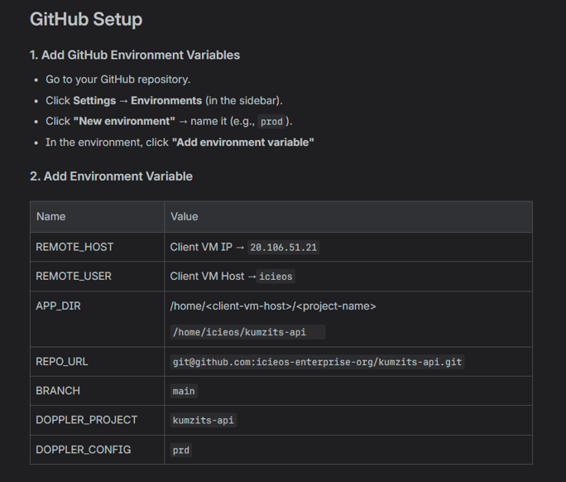
8. Some of repository, Jenkins and nginx configuration
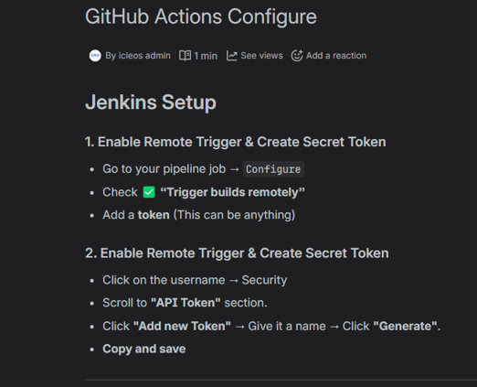

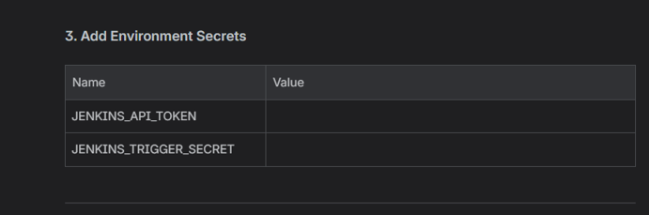
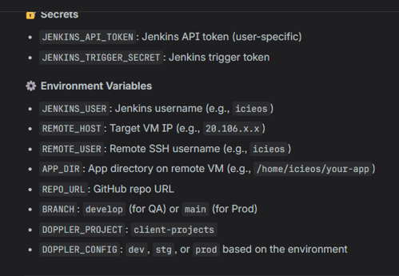
🚨 Root cause (confirmed) (in nginx config)
These two lines are breaking normal HTTP requests like /crumbIssuer:
proxy_set_header Upgrade $http_upgrade;
proxy_set_header Connection "upgrade";
Why this causes 400 Bad Request
Those headers are ONLY for WebSockets.
most correct ngix config for Jenkins without http headers upgrade like for scokets
location / {
proxy_pass http://localhost:8080;
proxy_redirect off;

proxy_http_version 1.1;

# REQUIRED HEADERS
proxy_set_header Host $host;
proxy_set_header Authorization $http_authorization;
proxy_set_header X-Real-IP $remote_addr;
proxy_set_header X-Forwarded-For $proxy_add_x_forwarded_for;
proxy_set_header X-Forwarded-Proto $scheme;

# Jenkins stability
proxy_buffering off;
client_max_body_size 0;
}

manage Jenkins -> security
CSRF Protection
Crumb Issuer
Enable proxy compatibility
9. Docker and docker compose files
docker file (node js api)
# Use an official Node runtime based on Alpine
FROM node:18-alpine

# Set the working directory in the container
WORKDIR /usr/src/app

# Copy the package.json and package-lock.json (if available)
COPY package*.json ./

# Install dependencies
RUN npm ci --only=production

# Copy the rest of the application code
COPY . .

# Bind the app to port 5005
EXPOSE 5005

# Define the command to run the app
CMD [ "npm", "run", "dev" ]

docker-compose.yml docker-compose-prod.yml
version: "3.8"

services:
app:
build:
context: .
dockerfile: Dockerfile
ports:
- "5005:5005"
environment:
- REDIS_HOST=redis
- REDIS_PORT=6379
depends_on:
- redis
volumes:
- .:/usr/src/app
- /usr/src/app/node_modules

redis:
image: redis:alpine
version: "3.8"

services:
app:
image: icieos/kids-plan-api:latest
ports:
- target: 5005
published: 5005
protocol: tcp
deploy:
replicas: 1
restart_policy:
condition: on-failure
resources:
limits:
memory: "1G"
networks:
- app-network

redis:
image: redis:alpine
deploy:
placement:
constraints: [node.role == manager]
networks:
- app-network

networks:
app-network:
driver: overlay

Add these docker file and docker-compose file to the repository.project root level and push a commit to the github, Now git hub triggeres the Jenkins pipeline and it will be build and deploy the project into the client virtual machine.
Let’s check this behavior
See the commit status from the github repository -> actions
Sign to the Jenkins dashboard and see the latest trigger, its status and console output
If those are successfully completed let’s inspect furthermore via the client virtual machine directly
sign into the client vm
check the respective container status
sudo docker ps
Sending request to the running container from the client vm itself
chamalka@free-vm-student-profile:~$ curl http://localhost:5008/api
{"status":200,"message":"Hello there !! Welcome to testing jenkins ci/cd pipeline API ! \n API is running successfully \n sec var: kingswood"}c
Now everything working fine within local to the client vm, Then need to configure nginx configuration for access from the outside. In advantage domain name and ssl certification can be configured also.
SAMPLE JENKINS CI-CD PIPELINE CLIENT

We are going to study on how to setup a Jenkins and docker base CI CD pipeline for a client application(react js application in this scenario)
All the initial previous action needed if we are using completely new different hosting servers either as a jenkin host server ot application host server
but at this moment we are using same servers; different repository
create client vm new directory “jenkins-hosted-client-apps” for clone the repository code.
1. GitHub new repository
2. Doppler new config -> add secrets -> generate service token for the config -> add to Jenkins
Doppler service token referred to single config for better security
But if you have a service account then service tokens with entire project scope can be created
If you don’t have service account you can create personal access tokens (PAT), but this Doppler Dashboard -> token -> personal
created new PAT and replaced into earlier created doppler-token inside Jenkins credentials
3. GitHub repository creating environments, variables and secrets
same as the earlier with respective different values (environment, variables and secrets)
4. Respective Docker and docker compose files
Following contents of these files

Docker file
# Stage 1: Build React App
FROM node:18-alpine AS build

ENV NODE_OPTIONS=--max-old-space-size=4096

# Set working directory
WORKDIR /usr/src/app

# Copy package.json and install dependencies
COPY package*.json ./

RUN npm install --legacy-peer-deps
# RUN npm install

# Copy the rest of the app files and build the app
COPY . .
RUN npm run build

# Stage 2: Serve React App with Nginx
FROM nginx:alpine

# Remove the default Nginx configuration
RUN rm /etc/nginx/conf.d/default.conf

# Copy the Nginx configuration
COPY nginx.conf /etc/nginx/conf.d/

# Copy React build files to Nginx's web root
COPY --from=build /usr/src/app/build /usr/share/nginx/html

# Expose port 80
EXPOSE 80

# Start Nginx
CMD ["nginx", "-g", "daemon off;"]

docker-compose.yml
version: "3.8"

services:
react-app:
build:
context: .
dockerfile: Dockerfile
ports:
- "3005:80"
restart: unless-stopped
deploy:
resources:
limits:
memory: 4G
nginx.conf (is this config file necessary or optional? )
We are containerizing this application. Within this process entire Nginx reverse proxy should be created to serve the container build output. This Nginx configuration file is used to create the internal reverse proxy of the new container
server {
listen 80;

server_name _;

root /usr/share/nginx/html;
index index.html;

# Serve static files and redirect SPA routes to index.html
location / {
try_files $uri /index.html;
}

# Optional: Cache static files for better performance
location ~* \.(?:ico|css|js|gif|jpg|jpeg|png|svg|woff|woff2|ttf|eot)$ {
expires 6M;
access_log off;
add_header Cache-Control "public";
}
}
5. Create github action and workflow
.github/workflows/dev-deployement.yml
name: QA Deployment

on:
push:
branches:
- main

jobs:
trigger-jenkins:
runs-on: ubuntu-latest
environment: dev

steps:
- name: Call Jenkins Build and Deploy Pipeline
run: |
curl -X POST "http://<jenkins hosted url>/job/Build%20and%20deploy/buildWithParameters" \
--user "${{ vars.JENKINS_USER }}:${{ secrets.JENKINS_API_TOKEN }}" \
--data-urlencode token=${{ secrets.JENKINS_TRIGGER_SECRET }} \
--data-urlencode REMOTE_HOST=${{ vars.REMOTE_HOST }} \
--data-urlencode REMOTE_USER=${{ vars.REMOTE_USER }} \
--data-urlencode APP_DIR=${{ vars.APP_DIR }} \
--data-urlencode REPO_URL=${{ vars.REPO_URL }} \
--data-urlencode BRANCH=${{ vars.BRANCH }} \
--data-urlencode DOPPLER_PROJECT=${{ vars.DOPPLER_PROJECT }} \
--data-urlencode DOPPLER_CONFIG=${{ vars.DOPPLER_CONFIG }}
6. Verify success or not
Check github actions
run sudo docker ps -a -> checking the image was created or not
run curl http://localhost:3008 -> should see html output
Finally configure reverse proxy setting to access this application from outside world
following nginx issue and fix >>>>>>>>>>
2025/12/24 19:05:55 [emerg] 119767#119767: could not build server_names_hash, you should increase server_names_hash_bucket_size: 64
nginx: configuration file /etc/nginx/nginx.conf test failed
if this arised whenever you tried to validate the correctness of ngix config file
This is most likely happening because of the long domain name. You can fix this by adding

server_names_hash_bucket_size 64;

at the top of your http block (probably located in /etc/nginx/nginx.conf).

I quote from the nginx documentation what to do when this error appears:

In this case, the directive value should be increased to the next power of two.
So in your case it should become 64. If you still get the same error, try increasing to 128 and further.

